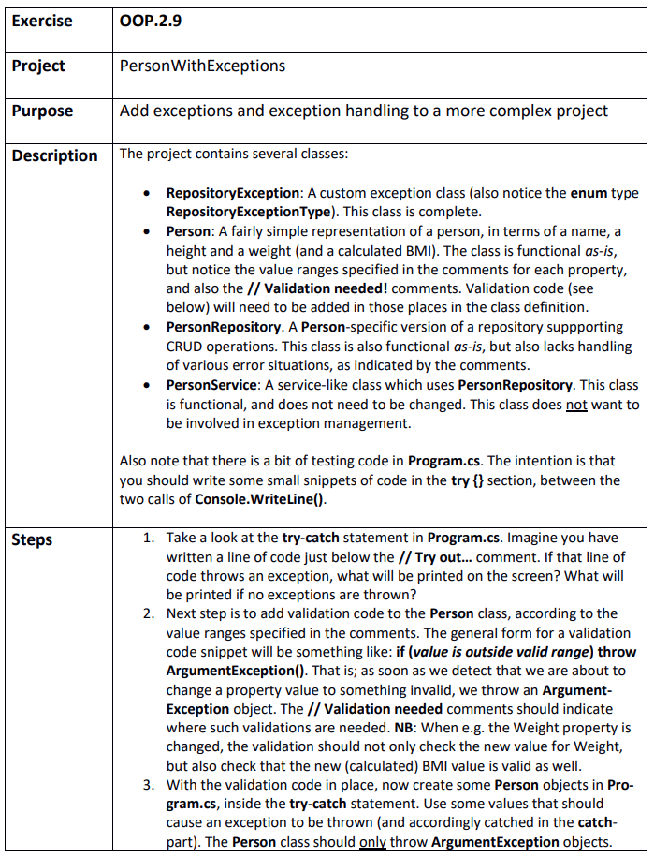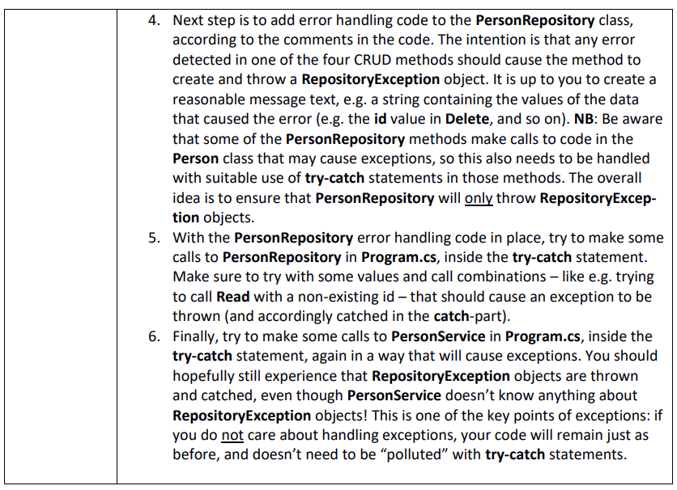

Step 1
PersonWithExceptions.sln
It depends on the exception which is thrown. Either way it would print out the message of the exception but also tell what type out of three types of exceptions. If no exceptions are thrown every writeline statements inside of the try block or the chain of methods in there would be written.

Step 2
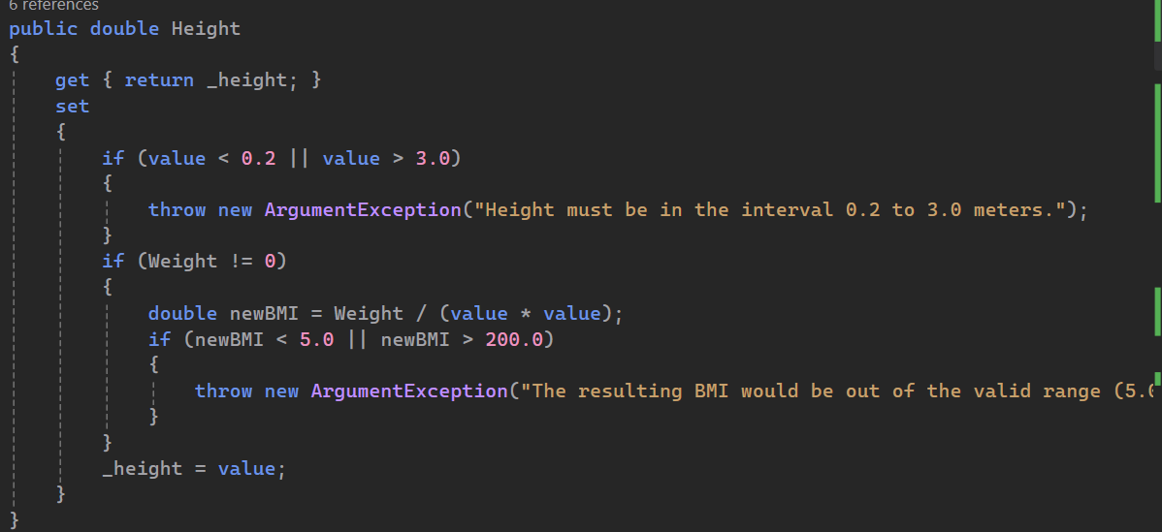

Step 3
Tested and found a missing validation due to instance fields being used over properties in the constructor…

Step 4
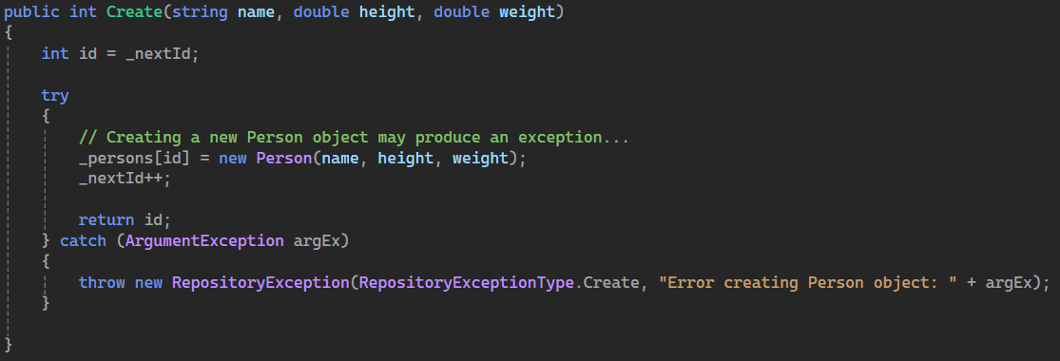

Step 5
Indeed

